# Changes to the Desktop

Changes to the Desktop 1

Loading the Desktop 1

Removal of Aero 2

File Explorer 4

Multiple Monitors 9

File Associations 14

Changing the default browser 15

Task Manager 16

New Task Manager 17

Task Manager Details 17

Screenshots 24

Try This: Changes to the Desktop 24

#### Timing for this module

|  |  |
| --- | --- |
| Delivery Length: 60 Minutes | Additional Lab Time: 20 Minutes |

#### Overview

While the majority of the changes that have been introduced with Windows® 8 have been focused on the new Windows UI, there have still been many changes to the classic desktop experience. These changes range from UI changes like the ribbon in Windows Explorer to the way that the desktop is loaded.

## Loading the Desktop

In an effort to reduce system resources and increase power efficiency, Windows 8 has made a change to the way that the desktop is loaded after you sign in. When you first sign in to Windows 8, you are taken to the new Start Screen in the new Windows UI. While you are at the Start Screen, the desktop is not loaded into memory. As long as you stay within the new Windows UI, including the Start Screen or any Windows Store app, then the desktop will not load or consume resources.

After you load the desktop by either clicking the Desktop tile (as shown in the screenshot below) or by clicking a tile for any desktop application, then the desktop will be loaded into memory and begin consuming resources. It will stay loaded for the duration of the user session until you either sign out or reboot the computer.

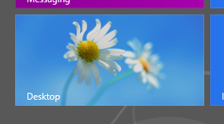

Figure : Desktop tile

The exception to this scenario is on computers with multiple monitors. On a computer with two or more monitors, the desktop will always be displayed on at least one of those monitors, so it is necessary to load it at sign on.

## Removal of Aero

The desktop interface has also been updated to align with the new One Microsoft design style, and as part of this update the Aero theme has been removed from the desktop. Aero is what enabled translucency and gradients present in windows frames for Windows 7. For Windows 8, the window borders are now opaque, displaying a single matte color with no gradients. By default, the Window color will automatically change to match the dominant color, as you see in the screenshot below.

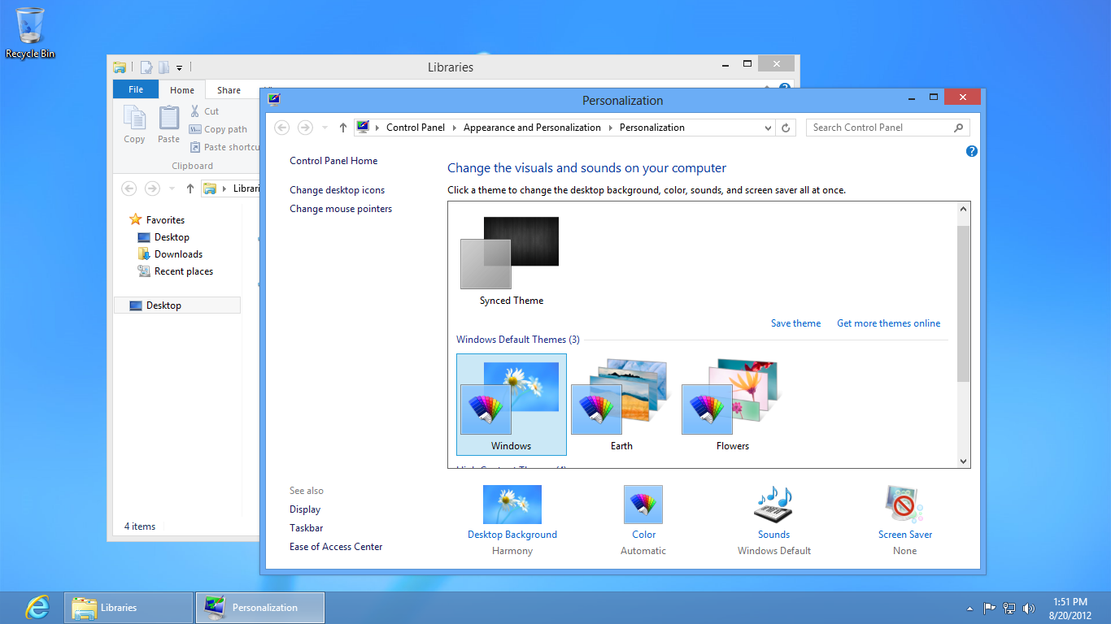

Figure : Window color matches dominant color in background by default

You can manually select the window color by using the Color and Appearance Control Panel, which you can access by selecting the Color button shown in the screenshot above.

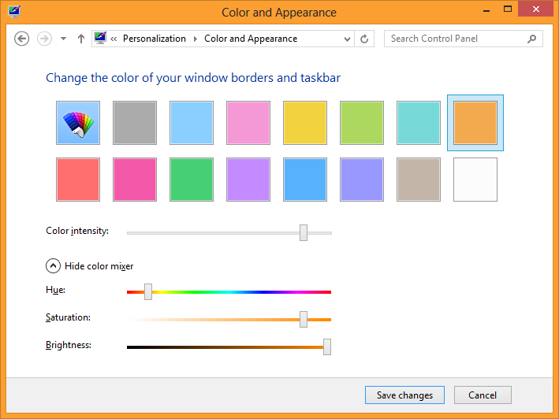

Figure : Color and Appearance Control Panel

**Note**: The taskbar on the desktop is still translucent.

## File Explorer

There have been many changes to File Explorer for Windows 8 (formerly Windows Explorer). The biggest is the inclusion of the Ribbon as part of Explorer. The Ribbon is part of the interface for Microsoft® Office applications and Paint and WordPad in Windows 7, and exposes the most commonly used options in Windows Explorer all in one easy-to-access location.

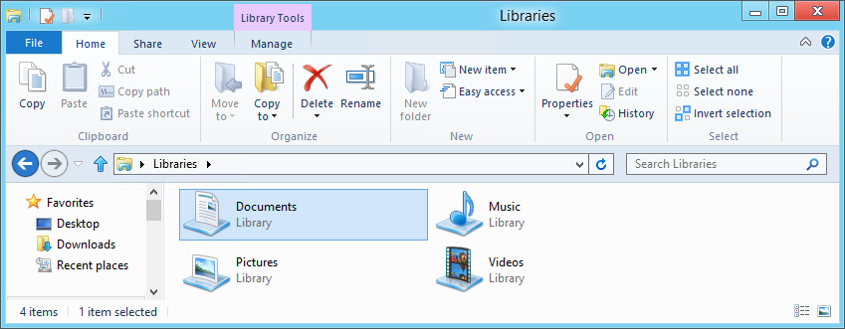

Figure : Windows Explorer and the Ribbon

**Note:** The new ribbon in File Explorer is minimized by default. You can expand the ribbon by clicking the arrow in the top right portion of the window, or by pressing CTRL+F1.

For more information about the changes in File Explorer and the motivations behind them, please read the following posts on the Building Windows 8 blog:

**Improvements in Windows Explorer**<http://blogs.msdn.com/b/b8/archive/2011/08/29/improvements-in-windows-explorer.aspx>

**Improving our file management basics: copy, move, rename, and delete**<http://blogs.msdn.com/b/b8/archive/2011/08/23/improving-our-file-management-basics-copy-move-rename-and-delete.aspx>

#### Key Points

* All file copies are merged into the same file copy interface with a separate progress bar for each file copy job.
  + The ability to pause and resume file copy jobs has been added.
  + The More Details view now shows a graph indicating the speed of the file copy.

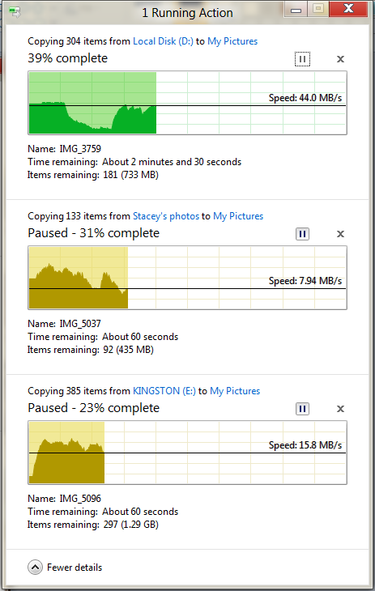

Figure : File copy dialog box

* A new conflict resolution dialog box for file copies has been added that provides many more details about the files you are choosing between.
  + Thumbnails are shown for each file, and larger and newer values are marked as bold.

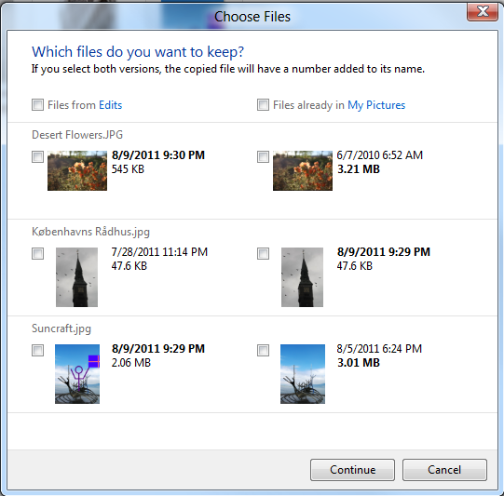

Figure : Conflict resolution dialog box

* The ribbon has been added to Windows Explorer, which exposes many (~200) of the top-level features in Windows Explorer, including several that were previously hidden in context menus that were only available with a Shift+right-click.
  + Every command in the ribbon is given a keyboard shortcut. Press Alt to reveal them.
  + Users can pin their favorite commands to the Quick Access Toolbar (QAT).
  + The ribbon can be hidden to maximize vertical screen space. Even with the ribbon visible, more vertical screen space is provided in the default configuration than Windows Explorer in Windows 7.
  + The ribbon is minimized by default.
  + The File menu includes options for things like opening a Command Prompt as an administrator, opening a new Explorer window, and clearing your history of recently accessed locations and documents.

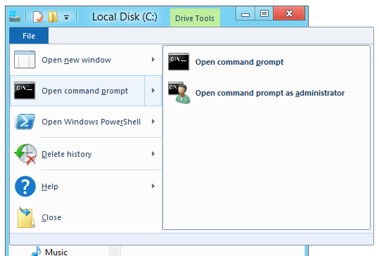

Figure : File menu

* + Contextual tabs are shown when selecting certain areas or file types in File Explorer. Some examples are shown below.

Table : Contextual tabs in File Explorer

|  |  |
| --- | --- |
| **Drive Tools** |  |
| **Library Tools** |  |
| **Picture Tools** |  |

## Multiple Monitors

There have been several changes introduced that will provide a much better experience for users that have computers with multiple monitors attached.

* **Corners and edges are active on all monitors**
  + Navigating with the corners of the screen with a mouse or with the edges of a screen with touch is part of the core navigation experience for Windows 8. It is important to support these corners and edges the right way on a PC with multiple monitors. Windows 8 does this by making the corners and edges of all attached displays active.
  + There is no concept of a single main monitor when it comes to the new Windows UI and Windows Store apps. The monitor that you access one of the corners on will be the monitor where that interface will display.
    - Accessing the Start Screen or previous app from the left corners will always open the UI on the display you accessed the corners from. This applies to the charms as well.
* **Easily move Windows Store apps to another monitor**
  + You can easily move Windows Store apps to another monitor by grabbing it along the top edge and dragging it from one monitor to another. If the app is snapped, it will be snapped on the other monitor as well.
  + You can also move Windows Store apps from one monitor to another using the keyboard shortcuts Win+PgUp and Win+PgDn.

**Note:** Windows Store apps can only be displayed on one monitor at a time.

* **Navigation along shared edges is improved**
  + On a PC with multiple monitors, one or more of the screen edges are likely to be shared. For example, two monitors sitting next to each other (where each has the same screen resolution) would share both the top and bottom edge of the screen. Because corners are so important for navigation in Windows 8, we need to be able to easily target each corner, but this is difficult when you can’t just throw your mouse in any corner like you can on a single monitor system.
  + To address this we have created real corners along shared edges, so that if you are targeting the corner, once you get there Windows won’t allow you to overshoot the corner accidentally. It does this by extending the corner along shared edges so if you are moving along the edge and hit the corner (within 6 pixels) the mouse will stop. You can think of it like a 6 pixel wall extending from the shared corner.
    - In the screenshot, the red lines indicate areas where you would run into a real corner.

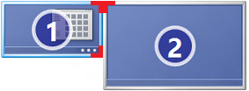

Figure : Red corners indicate real corner placement

* **Taskbars are now shown on all monitors by default**
  + With multiple monitors attached, Windows 8 will draw the taskbar across each monitor. By default, all taskbar icons are displayed on the main monitor, and the taskbar on all other monitors.

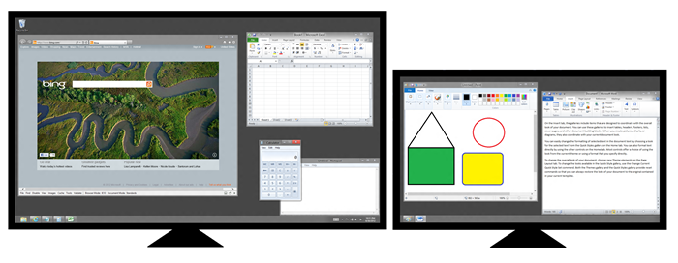

* + This is configurable in taskbar properties as shown in the screenshot below:

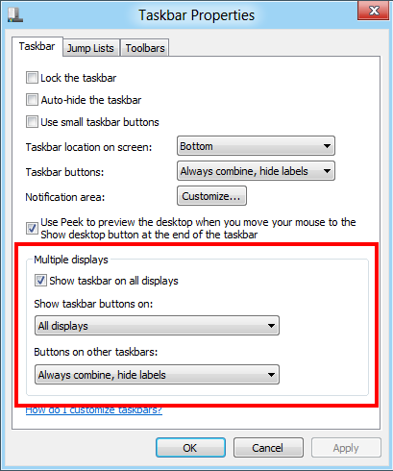

Figure : Configure multiple displays in taskbar properties

* + You can use the options control which taskbar icons are displayed on which monitor: All icons on all monitors, All icons on main taskbar and taskbars on other displays will only show icons on the display where the app is running, or only on the taskbar where the app is running.
* **Set a different background for each monitor**
  + You can now set different background for each monitor. When selecting a personalization theme, Windows 8 automatically puts a different desktop background on each monitor. You can even set a slide show to cycle through pictures across all monitors, or pick specific background pictures for each monitor.

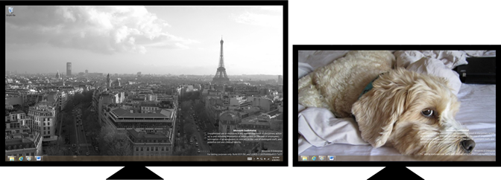

Figure : Different background on each monitor

* + When you right-click an image in the Personalization Control Panel, you will see an option to control which monitors the background will appear on.

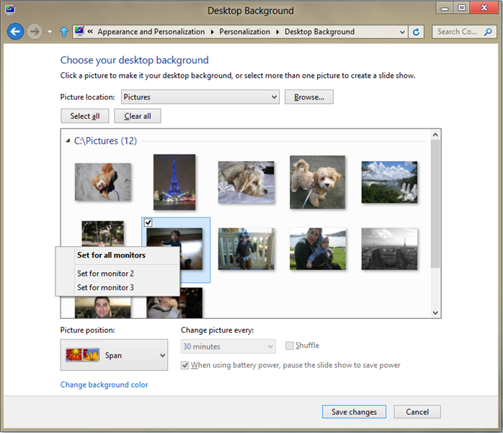

Figure : Setting backgrounds for each monitor

* **Multi-monitor slide show**
  + It is very typical for people to have a multi-monitor setup that consists of different sized and/or oriented monitors. And of course, not all photos look great in both portrait and landscape or on all screen sizes and resolutions. To address this, we’ve added logic to the slide show that selects the best suited images for each monitor.

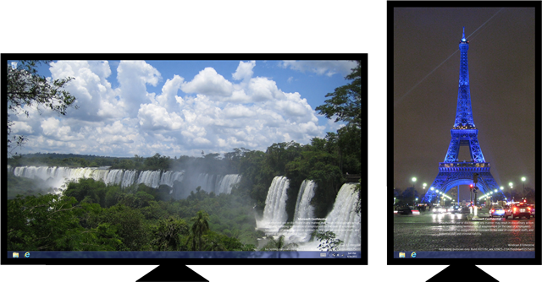

Figure : Windows automatically picks the right size and orientation for slide shows

* **Span desktop background across all** **monitors**
  + You can now span a single panoramic picture across multiple monitors. We are also including a new panoramic theme in the personalization options for Windows 8.

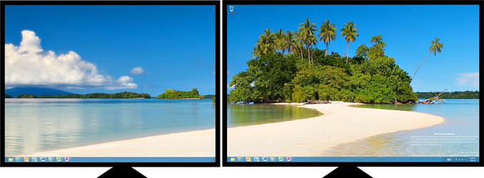

Figure : Spanned desktop background

* + To set this up, pick a panoramic desktop image and select Span as the picture position.

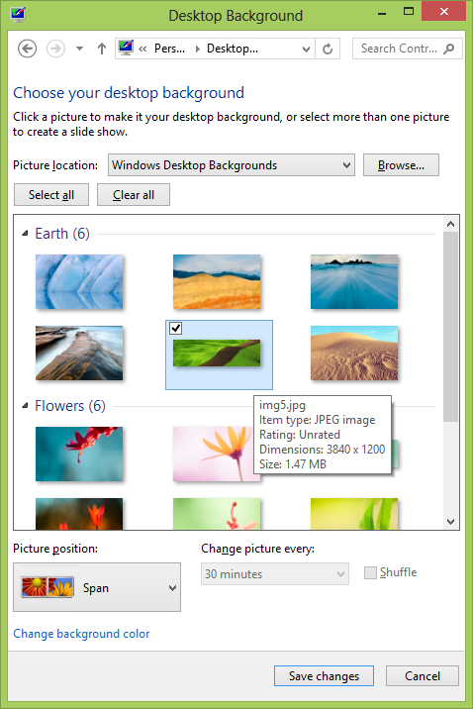

Figure : Set up background image spanning

## File Associations

Windows 8 has changed the way that file associations are handled now. Previously, any new app that supported a given set of file types would try to automatically set itself as the default handler for those file types. Sometimes it would ask, other times it would not, but the end result was that users were left feeling like they were not in control of their file associations.

Now, when a new app is installed and it registers itself as a protocol or file type handler, instead of just allowing that registration to take effect automatically, the next time that the user attempts to open one of the file types that the app registered to handle, Windows will prompt the user to choose which app they would like to open the file in.

The user can also easily change their selection at any point in the future by selecting the drop-down arrow next to Open in the Windows Explorer ribbon.

### Changing the default browser

While the apps that most commonly attempt to steal file associations from each other are multimedia apps, this change also affects web browsers. Now, when any browser attempts to mark itself as the default browser (which makes changes to the default protocol and file handlers for things like the HTTP protocol and HTML files), those changes will be ignored.

Now, when a new web browser is installed, instead of allowing it to automatically set itself as the default browser, Windows displays a notification to the user showing that a new browser was installed. This notification is shown in the screenshot below.

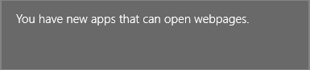

Figure : You have new apps that can open webpages

Clicking the notification displays a second dialog box from which you can choose between the available browsers installed on your PC:

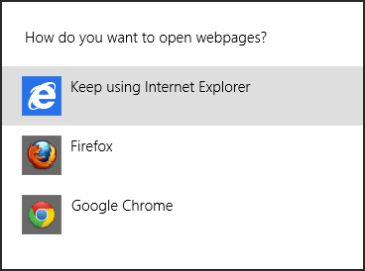

Figure : Select the browser you would like to use as the default

If you miss the notification, or wish to change the default browser after the installation, you can change the default browser by going into the Default Programs option in the desktop Control Panel. From here, select **Set your default programs**. This will open a window displaying all of the apps that are registered to handle specific file types or protocols. From here, select the web browser that you would like to make the default and click the **Set this program as default** button.

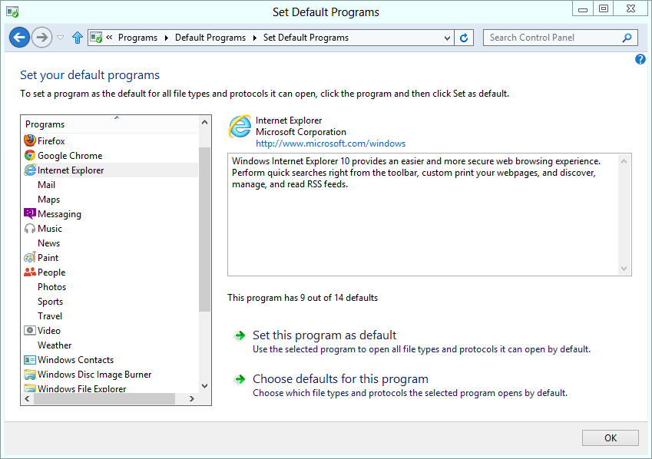

Figure : Set default programs

**Note:** Internet Explorer 10 no longer uses a Make Default button in Internet Options.

## Task Manager

Task Manager has been significantly updated for Windows 8. As part of this update, it has been given a simpler basic interface design, as well as a much more capable detailed view. Its expanded capabilities better match the ways it is used for troubleshooting.

Specific changes include:

* Simple initial interface with list of running apps and **End task** option.
* Detailed interface with these new capabilities:
  + Clearer relationship between apps and processes.
  + Easy-to-read performance metrics per process.
  + Expanded PC performance information – similar to Resource Monitor default view.
  + App performance history
  + List of Startup programs, with option to disable.

### New Task Manager

The new Task Manager is opened from the Windows interfaces where you can access Task Manager by name – the Windows Security screen, right-click menu on the Taskbar, pressing Ctrl+Shift-Esc, etc.

When you start Task Manager, it opens to a very simple view that shows only the current user’s running apps by default.

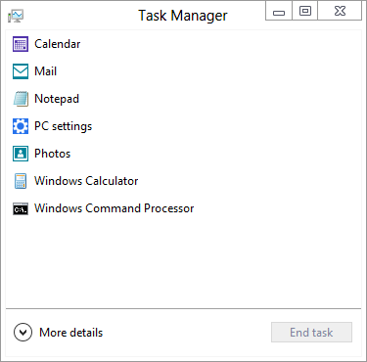

Figure : Task Manager

This view is intended to provide a clear, concise list of running apps to make it easier for a user to select and end a task. This is an improvement for our non-technical users who might have been confused by the more complicated interface in the older Task Manager.

### Task Manager Details

The **More details** link at the bottom of this view expands Task Manager to show the full interface.

#### Processes

The Processes tab shows running apps and background processes. Where a process has multiple windows open, this is shown to the user as a number following the process name, and a control to expand the view to see these window names.

Processes are listed in alphabetical order in groups, by default. The order can be changed by clicking any of the column names.

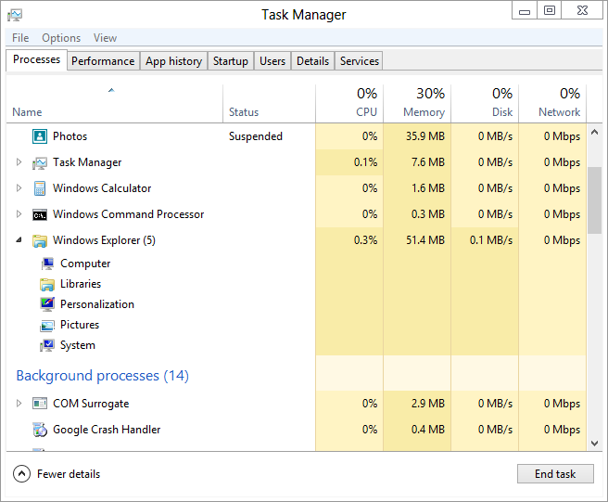

Figure : Processes tab

Some background and system processes also provide an option to expand and view child objects. This is the case for processes that are hosting a service. Expand the process to see which service(s) are running in the process.

This should help make service performance issues much easier to diagnose, compared with the older Task Manager interface, which showed processes and services separately.

#### Performance

The Performance tab shows graphs and details of the 4 key PC performance metrics. Also, note the **Open Resource Monitor** link at the bottom, providing a path to this other interface when you need to do additional troubleshooting.

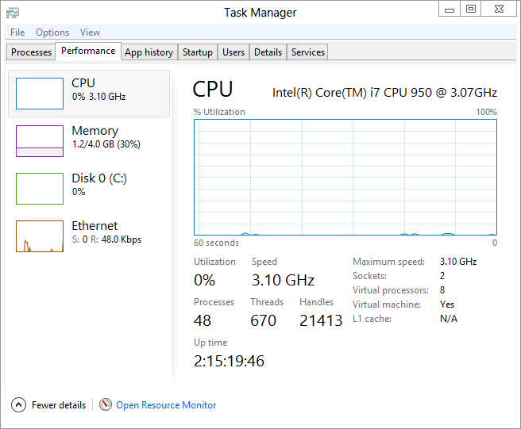

Figure : Performance tab

#### App History

The App History tab shows the total resourced used by individual apps since Windows was installed, or since the last time the usage history was deleted. Clearing that usage history is an option just above the list of apps.

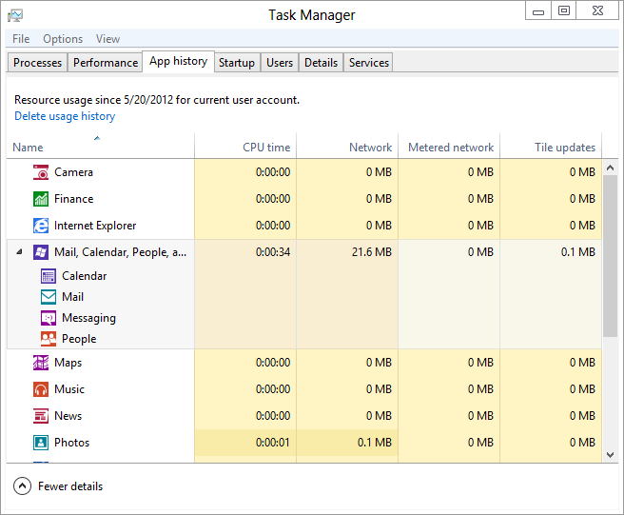

Figure : App history tab

This tab can be useful to understand which apps may be using a large amount of network bandwidth, or finding which may be reducing battery life by consuming a lot of CPU time.

#### Startup

The Startup tab is another useful troubleshooting feature in the new Task Manager. In addition to showing all of the non-system startup items in your configuration, there is a startup performance impact assessment. This will show as **Not measured** for some time when new items are added to the startup configuration. When sufficient data has been collected, this will show an impact level – High, Medium or Low. Meeting the threshold shown in the table below for either disk or CPU will determine the startup impact.

Table : Startup Impact Levels

|  |  |  |
| --- | --- | --- |
|  | **CPU Usage** | **Disk Usage** |
| High | >1 seconds | >3MB |
| Medium | ~800ms | ~1MB |
| Low | <300ms | <300KB |

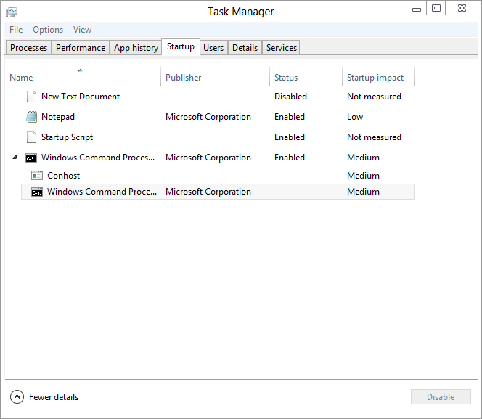

Figure : Startup tab

To disable an item, simply right-click and then click Disable. This can help make Task Manager a useful tool not only for cleaning up the running configuration, but also to help in ad-hoc startup troubleshooting.

**Note:** This tab replaces the functionality of the **Startup** tab in MSConfig, which now says **To manage startup items, use the Startup section of Task Manager.**

#### Users

The Users tab is where you can go to view the processes running in each user’s session. This differs from the old Task Manager interface where all users’ processes were shown on the Process tab.

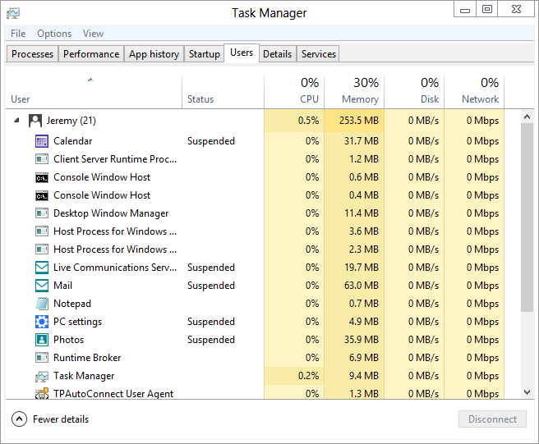

Figure : Users tab

You can use this interface to see which user account a specific task is running under, so you can troubleshoot that specific account. You can also use the Users tab to log off another user, switch to another user, and end tasks running under another user account.

#### Details

The Details tab is where the new Task Manager interface provides the same column selection choices and process list as in the old Task Manager. This is useful for viewing all processes together, or if sorting by a cumulative performance metric is needed.

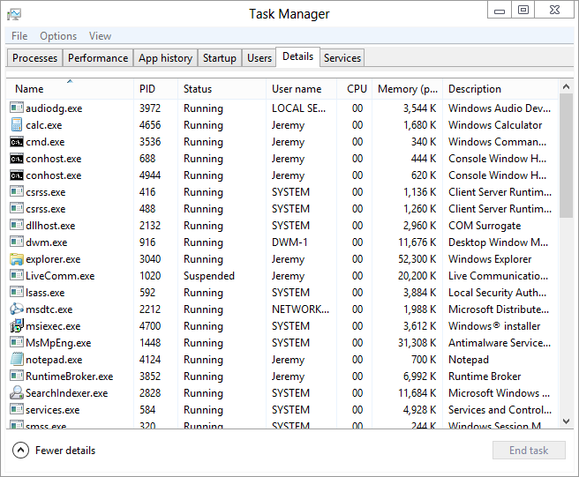

Figure : Details tab

#### Services

The Services tab is the last tab in the details interface. As shown below, this gives a view very similar to the old Task Manager.

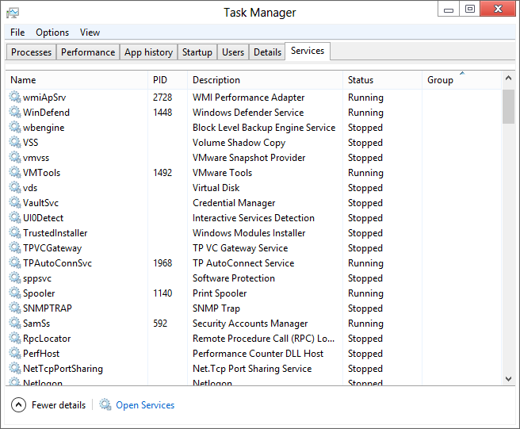

Figure : Services Tab

## Screenshots

Windows 8 now has native support for taking screenshots. On your keyboard, press Win+PrtScn and you will see the screen dim slightly for a second to indicate that the screenshot has been taken.

* Your screenshot will be saved automatically to a folder in your Pictures library called Screenshots.
* The default file name is Screenshot (*#*).png (where # is a sequentially ordered number starting with 1).

On tablets that are Certified for Windows 8, you will be able to take a screenshot by holding down the power button and pressing the hardware Windows button. This must be supported in the firmware of the tablet, but all tablets that carry the Windows 8 logo will support this.

## Try This: Changes to the Desktop

* Try using the ribbon to do the following:
  + Copy the path to a folder.
  + Open an administrator Command Prompt.
  + Show hidden files and folders.
  + Show file extensions.
* Take multiple screenshots using the new keyboard shortcut.
  + Where did Windows save the screenshot?
  + What image format is used?
* Open the new Task Manager.
  + Using only Task Manager, answer the following questions.
    - How many sockets and cores does your CPU have?
    - What is your IP address?
    - How large are your hard disks?
    - What happens when you double-click any of the graphs in Task Manager?
    - Which apps have used the most CPU time and network bandwidth in their lifetime?
  + You find that one instance of SVCHOST.exe is showing heavy CPU usage. How can you identify which Services run in that instance of SVCHOST?